


www.nnr-scotland.org.uk www.tentsmuir.org

TENTSMUIR NATIONAL NATURE RESERVE

NEWSLETTER No. 21

JUNE 2009

Welcome to the summer edition of the Reserve Newsletter. We bring you some really exciting stuff - wonderful observations, management updates, new species, some excellent feedback from visitors and volunteers and news about the forthcoming Family Day Event: Monster Fun.

In contrast to the winter issue of the Reserve Newsletter the weather has improved, sunny warm days with the occasional wet day - I am trying to cheer you up it’s just our typical Scottish weather. One theme from the last newsletter was about how easily our moods can be uplifted in the great outdoors, it is one of the best pick-me-ups ever. It’s a healthy message delivered everywhere and its great meeting people on the Reserve who have that satisfied smile on their faces. Be inspired to write some poetry or prose or a letter just like the lovely letters inside and let me know how you feel about the Reserve, the flora and fauna, just lose yourself in the world of words. It’s just amazing.

What’s going on in this edition? Once again the last six months have seen another tremendous amount of management and monitoring work carried out, a fair part mostly unseen, until now! One of the worst kept secrets is finally revealed. I’ll tell you about my colleague Alex “Kingfisher” Easson, what a lucky man! I have had a great response from visitors and volunteers and you can read about their experiences and thoughts about the Reserve.

Visitor feedback about our new interpretation structures and interpretation panels and cartoon style behavioural panels continues to be very positive and enjoyed by everyone.

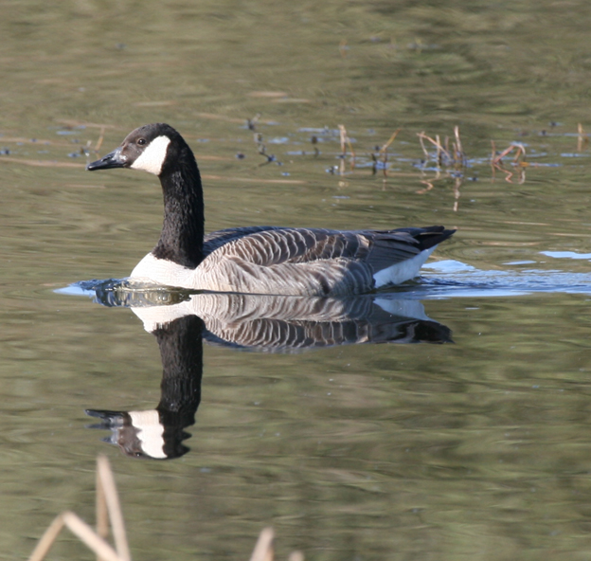

Canada goose reflections by Jacqui Herrington

Tom Cunningham
Reserve Manager

TENTSMUIR NATIONAL NATURE RESERVE

TENTSMUIR POINT

Have you come across the new interpretation structures, interpretation panels and cartoon style behavioural panels yet? Let me know what you think?

Have you had a look at our bespoke website, www.tentsmuir.org yet? We update the website regularly, so find out what’s going on the Reserve and in this local area!

April was a very warm, sunny month and butterflies started emerging; orange tips have had a great period with numbers up on last year at Tentsmuir Point and Morton Lochs. Other early observations included peacock, green veined white and good numbers of small coppers. Of course, the sun we enjoyed in April, didn’t last too long and early May was disappointingly wet and windy with the sun not appearing until late in the month.

The site is greening up well and in some areas the bright yellows of the cowslips and primroses showed their vivid splashes of yellow against the dull remains of last year’s grass, with the tiny purple flowers of violets and common vetch and the beautiful purple head of the northern marsh orchid appearing throughout the heath and dunes adding to the Reserve’s rich palette.

Watch out for the rainbow procession of colours across the landscape; the colourful yellow & orange birdsfoot trefoil is one of my favourite plants, and has delightful folk names such as eggs & bacon and Tom Thumb. Soon the crisp white petals of one of the Great Slack specialities, grass-of-Parnassus, yellow rattle and the pinks of the centaury family will blossom in the sun. This year has already seen an increase in the delicate creamy spikes of coralroot orchid with ten observed in one site, contrasting to the declining numbers recorded over the last few years.

The Reserve leaflet will shortly be on display in the dispensers in the Forestry’s new visitor shelter at the car park and of course you can always stop me, Alex or Bid to ask for one.

MANAGEMENT

The Limousine cattle will shortly return to the site and enjoy their second summer grazing by the sea. Local farmer Robert Lamont of Scotscraig Farm was very happy with the cattle’s condition and relaxed temperament and we were delighted with effect of the grazing regime over the dune system.

Included in the many management tasks we achieved over the last six months was the annual maintenance of the sea fences and boundary fences, hand pulling the target tree species and the control of grey squirrel and crows.

Elmwood College conservation management students have been monitoring squirrels for the past two years and their data suggests there are very few grey squirrels in this area, reflecting on the success of this task. Crow control in the Reserve and forest was hugely successful; take a walk on the Great Slack (north end of the site) and listen to the skylarks and stonechats, look around for the other species such as meadow pipits and of course the summer aeronautical acrobatics of swifts, martins and swallows.

We are about to start a massive herbicide programme with David Mackie and his team working alongside Reserve staff, who will continue spraying our target species in the Reserve and Tayport Heath. We are particularly pleased with the work carried out over the last 12 years adding to the real value of the Reserve.

THE DYNAMIC COASTLINE

Erosion in the old observation tower area, now called the Green Hut area, eased this winter and we estimate the erosion was only one metre, considerably less than in previous years. The sea pushed flotsam well in land to the north of this site, but thankfully erosion was negligible and the flora should push its way through the sand and the mainly natural sea debris.

To the south of the Reserve the accretion continues and it is quite incredible as the dune edge continues its growth towards the sea with marram and lyme grass colonising. A remarkable large dune front is growing further out at sea and this may build up to be a sheltering edge safeguarding the delicate dunes on the landward side. However, who knows, the sea is the master here.

The northern finger of sand dune continues to creep into the Tay and hopefully the sand dune system will continue to grow behind it. These are both excellent areas to observe and study plant colonisation and sand dune development. If you would like to know more about these fascinating studies please contact me for further details.

EDUCATIONAL PACK

Just to remind everyone the second edition of the Education Pack was printed and distributed to every school in Fife, Dundee and Angus, as well as requests from schools further a field. This magnificent education resource can be enjoyed by everyone, have a go with the activities and the benefits by looking at the pack on our website – see the front page.

It’s been a bit quieter than I would hope over the winter and spring months with a few schools coming in, a sign of the times perhaps or just the wet weather? We did however, welcome 18 students and teachers from Lycée Alfred de Vigny High School in France who enjoyed their third trip to see the Reserve and who were shown around by Alex Eason (who ate all the chocolates!)

TENTSMUIR INTERPRETATION PLAN & LIAISON GROUP

The wonderful behaviour and interpretation panels which were created in a cartoon style have been well received by visitors, with positive comments made to Reserve staff or left in observation books in the hides. I am always keen to know what visitors think so please let me know.

Our Forestry colleagues will soon have their interpretive shelter nicknamed ‘the spider’ constructed in the picnic area at the car park, and further structures in various parts throughout the forest. The River Eden Centre bird hide at Gaurdbridge will also soon benefit from updated and new interpretation.

New designated walks have also been developed and these will soon be signposted through the forest and reach as far as Morton Lochs. Look out for the waymarkers, the specific symbols and routes for the Feathers walk, Seashell walk, habitat trail, pinecone walk and the Eden Estuary walks.

WILDLIFE UPDATE

Have you heard the distinctive call of the cuckoo this season? The cuckoo was recently added to the list of 52 species featured on the Red List of the Birds of Conservation Concern, which is not good news. However, I am pleased to report that after a lapse of some three years I heard the distinctive call at the end of May! The bird was calling in the Icehouse area and it must have been scouting for an unsuspecting meadow pipit nest. The Cuckoo is a brood parasite, and lays its eggs in other birds' nests and leaves the host birds to incubate and rear their lodger as one of their own. Reed buntings, robins, dunnocks and meadow pipits are frequent host birds. The Cuckoo specialises in using a particular host species, laying eggs with similar markings to the host bird's eggs, and the young Cuckoo will imitate the begging calls of the host's chicks. When the Cuckoo nestling hatches, it instinctively pushes the other eggs and nestlings out of the nest.

Other wonderful observations made include a ringed plover with four little fluffy bundles of speeding chicks. A very lucky Tayport man walking along Tayport Heath observed an osprey catching a sea trout off Green Scalp only for it to be mobbed by gulls and dropping its prey. What a sight!

At least two new species and a further five invertebrate species awaiting confirmation have been observed. Simon Hayhow, an invertebrate expert, observed the pinewood hoverfly Callicera rufa which is a first in Fife. These hoverfly breed in a particularly specialised way and in order to boost and stabilise populations we have established artificial rot holes in pine tree stumps. Simon also observed a bee, Osmis caerulescens which is only the second record ever in Scotland and two wasp and two true flies’ species. Many thanks to Simon for sharing these wonderful observations.

Walking along the foreshore have you had the feeling it was ‘watcher being watched’ and you have to ask yourself, ‘I wonder what they are thinking’ as they follow you along the coast? Please be aware there are a few seal pups around and they can be stressed out by visitors getting too close. Please stay a suitable distance away, keep all dogs on a short lead to reduce the stress in their lives.

Many bird species on Tentsmuir Point enjoyed a good spring and already the summer visitors are settling in. Many thanks for the good observations by Bill Alexander, Ruth and Paul Blackburn and Reserve staff. For example grey plover (690), ringed plover (176), golden plover (51), gannets (960), curlew (220), oystercatcher (920) and red breasted merganser (108) have had a great year and are just a few of the bird species around.

Red squirrel numbers are good throughout the forest and Reserve and butterflies have had a stop go start to the season, possibly as a result of the damp colder weather, with orange tips having a great season and a far longer one than I can remember.

Is the recent decline in the coral-root orchid over? By the 2nd of June we had observed over 35 floral spikes of this lovely orchid. This is earlier than we normally see the orchid perhaps it’s a new trend for the plant. Let’s hope the recovery is on.

MORTON LOCHS

MANAGEMENT

In a very busy period Alex, forester Graham Paul and many volunteers carried on their much appreciated hard work controlling the gorse throughout the north plantation and the south loch. Contractor Dave Mackie and team came in for a few days and chipped the gorse brash which will be spread on the south loch wild footpath. The work they carried out is of an exceedingly high standard and continues to exceed our expectations.

The Scotscraig farm cattle have just returned and we hope again the grazing will be fruitful to both the cattle and the grazing management of the site. Once again I am grateful to Robert Lamont, sons Rob and John and cattleman Jock.

Elmwood College Conservation Management NC students have enjoyed gaining work experience carrying out management tasks on the Lochs site. Hope you enjoy their shared thoughts later in this issue.

At last the Morton access road has been regraded and the journey up to the car park is smooth. The car park has been resurfaced with quarry material as well and my thanks go to Jock Henderson of the Forestry road squad for carrying this out.

Many of you would have noticed earlier that the old south railway ditch was a fascinating frenzy of mating frogs and toads and we should soon witness the mass migration throughout the lochs as the young frogs and toad move into the undergrowth.
The west loch spillway was replaced and we are now able to control the water levels that bit better.

Management planned for the summer months include: herbiciding the target species including reeds, bracken, gorse and broom; a mammoth task but we are winning.

Volunteer Andrew Ford continues the management of collecting data from our hydrological monitoring system around the Morton Lochs and surrounding area which will give us a better understanding of the hydrology of the area.

WILDLIFE UPDATE

There have been some great sightings, good moments and some sad news around the Lochs.

A few of you observed the beaver over the last year, I know it was a hot topic amongst visitors and media, but this was an illegal release of the animal and one which had to be recovered. The beaver was trapped by experts from Edinburgh Zoo and Science and Advice for Scottish Agriculture and it will probably spend his time now at the zoo.

The otter has been also observed by many visitors and by my colleague Alex - by the way this is Alex Kingfisher Easson who observed four, yes four kingfishers in one ten minute spell while out patrolling. Lucky man! I’m never out there when it’s been this great!

The mute swan pair on the north loch settled down and hatched eight eggs and while one cygnet has perished the remaining seven are growing by the day. The south loch pair settled down much later and the female was still sitting on the nest the other day.

The bird hides are well used and visitors to the Len Fullerton bird hide have enjoyed sitting looking through the new viewing windows. Reed buntings and chiffchaff are just two of the many visiting species to the lochs and have been photographed by Jacqui Herrington, as well as Canada geese, the mute swans and kingfisher.

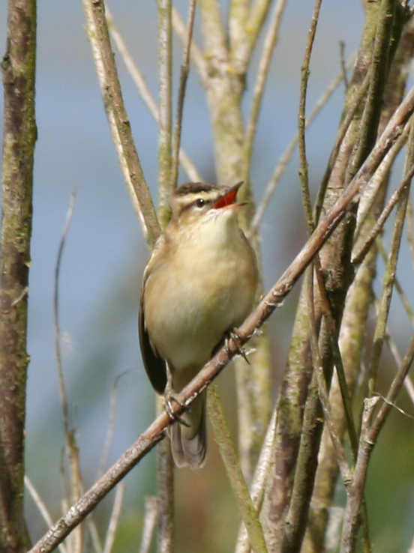

Sedge Warbler by Morton Lochs by Jacqui Herrington

IRRESPONSIBLE VISITORS
Local man Alastair Troon wrote into to tell us about his experiences on a day out on Tentsmuir:

‘Seals and dogs at Tentsmuir.’

On a recent Sunday visit to Tentsmuir my wife and I were pleasantly surprised to find the resident seal colony basking on the main lagoon just inside the Nature Reserve fence. Admittedly, while we had not read the advice displayed by the car park regarding what to do in such a situation, we considered it common sense not to approach them, and returned to the main beach to carry on in the direction of Tentsmuir Point. As we returned within sight of the colony, increasing numbers of visitors were approaching the lagoon, most thankfully keeping their distance. However, sudden barking signalled one family’s blind disregard in taking two dogs without leads right on to the lagoon in full view of the seals, with the larger of two dogs herding these previously contended creatures into the water.

When the dog was then belatedly tethered, the family marched on with one dog still off the lead; evidently no wonder of nature was going to get in the way of their walk. In the direction they were heading we had previously spotted a seal pup on the sand at the edge of the water, with what we assumed to be two parents swimming just offshore. I shouted across from the main beach to warn the family of this, but incredibly they just kept on going with the smaller dog un-tethered, the only response being that the pup must be ‘sunbathing’. Sure enough, an eruption of barking and snarling minutes later told us that the smaller dog had encountered the seal pup, and again belatedly the dog was restrained. This kind of behaviour by dog owners goes beyond the disgusting practice of bagging but not binning that can be seen widely around the car park area. Surely we don’t need to be budding David Attenborough’s to understand that seals are wild animals and not accustomed to close contact with humans, never mind dogs whose owners cannot seem to understand how threatening their pets might seem to these shy creatures. Seals suffer great stress in such situations, and pups can be abandoned. There are many responsible dog owners who take their pets to Tentsmuir: I’m sure their empathy for this precious environment ensures that they enjoy it all the more. SNH have informed me that incidents such as the ones we witnessed are on the increase. Perhaps those who cannot comprehend how lucky we are to have such a gem of nature on our doorstep should instead imagine seeing seal colonies such as this only in books and on TV”.

It’s a pity a day out can be spoiled the actions of others.

DOG POO!

The usual problem continues and there has been quite a bit of this in the local and national newspapers, local residents in Tayport as well as visitors have been writing away, perhaps you may have read them.

The problem of dog poo left around by irresponsible dog owners is still showing no sign of improving; I’ve even put up temporary signs highlighting this disgusting behaviour. It’s no one else’s responsibility of clearing up dog poo and removing and disposing of the dog poo bags – it’s yours!

BAG IT. TAKE IT HOME TO BIN IT!

KIDS CORNER

I’ve always wanted to let our younger visitors express themselves and let me know what they think of their day out on the Reserve. It’s very important to hear their point-of-view, and I’ll listen, that’s for sure. So please let me know, email or write me a story about what you saw, how you felt, or if there anything you would like to do or see on the Reserve sites?

The first thing I would like is that perhaps you can suggest a better title for your own section in the Reserve Newsletter – I’m sure you can!

POETRY CORNER

There is no silence here but peace.

Winter long gone and trees now gowned
and branches green unfurled and
from where unseen birds chorus my slow step on last year’s pine.

I turn my head towards the sea and hear the siren
call of seals and pups as I’m climbing the gentle slope
of the great slack wall.

By volunteer and regular visitor Pete Cunningham

WHAT’S ON

9th July 2009 - FAMILY DAY OUT, “Monster Fun”.

The tenth free annual NNR event will be held on Thursday 9 July and it should be an exciting day out.

The new style shorter activity sessions were a great success last year, and we will continue with them, please be patient, enjoy, learn and try several different ones. Each activity will last 20 to 30 minutes; you finish one and then move onto the next one. Staff and volunteers will help you moving on.

In addition to the short events and activities in store for you, we have a very special guest, Dr Bunhead who will delight, enthral and entertain you with his scientific fun!

Once again there will be tea, coffee, fruit juice and a biscuit and if you’re good a cake, maybe!

The activities include:

- Make wildlife creatures.
- Different beaks for different food.
- Leaf art.
- Nature wild art.
- Nature Fun for the under fives.
- Sketch & paint for the older visitor with Dave Mitchell.
- Nature treasure hunt.
- The viewpoint telescopes and all the staff and volunteers will be happy to answer your questions and help you enjoy the day out.

With the exception of the £1 charge for the car park, it’s all free!

There are 120 places available and the event books up fairly quickly. I also keep a reserve list, as there is usually a visitor or two who may have to cancel suddenly. If you are unable to attend after booking, please contact me as soon as possible to let me know, so I can call and let someone else take up your place. Please don’t let me or other visitors down. Remember all children must be accompanied by a responsible adult.

To book, please phone my office telephone and if I am not in, please leave a short message on the answer machine, with your name and telephone number and I will contact you to confirm the booking. If I do NOT contact you, you are not on my list!

VISITORS & VOLUNTEERS

I’ve had a great response from volunteers and visitors and below there are several letters from some wonderful people:

Lynda Oxley a student from Elmwood College conservation management enjoyed a week volunteering on the Reserve recently and these are some of Lynda’s thoughts.

‘On my very first visit to Tentsmuir NNR I fell in love.

I fell in love with the amazing sand dunes, I was not aware that there was somewhere so beautiful just 30 miles from my house. The area is so peaceful and calming, a great place to come to get away from it all which I often do when I’m feeling a bit stressed, and I am instantly relaxed the second I drive through the gate.

I fell in love with the great walks through the forest; with so many different paths you can have a new walk every time. The forest is also a great area to take my 5 year old (adventurous) son; he has such fun making up games (usually super hero games) and running in and out of the forest, and loves riding his bike up and down the tracks. He loves it when he catches a glimpse of a red squirrel, or gets to see the seals hauled out on the beach. There is just such a variety of things to do here that suit every mood; you really don't have to go anywhere else.

The more I visited, the more I wanted to know about the area, so when I got the opportunity of a week's work placement I jumped at the chance. Being there all week working alongside the Reserve staff has taught me so much about the area and its integrated management between Forestry and Scottish Natural Heritage, and the specially designated areas and what they mean. I got the chance to help out in the daily running of what is to me, the most magical place in Fife. This is something I will never forget and will always appreciate. The chance to give something back to an area that is so special and has served me and my son so well.’

Iain Jamieson, a stalwart volunteer and student from Elmwood College wrote,

‘Since I was a child I have regularly visited Tentsmuir and Morton lochs, often to escape the daily hum drum and have a wee quiet wander. I never had to look far to see something interesting, as the area is teeming with wildlife, whether it be red squirrels, woodpeckers, seals or any of the other features and treats the reserve has to offer.

Nowadays, I volunteer on the reserve and have been surprised by how rewarding it can be to give something back to a place I have enjoyed for so many years, even gorse removal if you have the right gloves!

I have had a fantastic time, gained a lot of experience and would recommend volunteering to anyone with an interest in the outdoors. But please, remember to bring plenty of cakes as the staff need their strength!’

(Ian is so keen, he sometimes walks or cycles the eight miles to get here!)

Long time volunteer and nature enthusiast Andrew Ford wrote,

“Well, I’m now into my fourth year as a volunteer, and many more as a visitor to Tentsmuir National Nature Reserve. My experience has broadened as I am now collecting the monthly data from the hydrological monitoring system around Morton Lochs.

Over the years I have had great experiences and taken many memories away with me; working with the brilliant reserve staff maintaining the tracks and visitor facilities and with work parties carrying out habitat management on the Reserve. I have assisted a local contractor with their work on the Reserve and carried out many wildlife surveys around Morton Lochs and at Tentsmuir Point, and I have had some amazing wildlife experiences. One of many was when I sitting in the hide and a Kingfisher appeared ten metres away from me, fishing from a post. This was the first time I had seen a kingfisher other than on TV.
As a visitor to the reserve one summer’s night, I was standing on the access track between the North and South Lochs at Morton. I could see this shape swimming towards me, getting closer and closer. I realised it was an otter. It swam towards me until it was about five metres away before it suddenly realised I was there, and started swimming backwards, hissing at me. I was just in the right place at the right time for the previous two wildlife encounters. Tentsmuir NNR is a magical and wonderful place to volunteer and visit.

WALKS & TALKS

Want to know more of what we do, or just want to see the wonderful sights on the Reserve? If you have a few friends or a group who fancy a guided walk or talk about the Reserves, please contact me. If you would like to see how effective the management of the Reserve is, or observe a little more of the hidden secrets and gems, then give me a ring and I will arrange a guided walk or talk.

I look forward to seeing you on the Reserve sometime.

BIG THANKS

Many thanks to all who contribute to the Newsletters and the valuable data collected for our flora and fauna records and to the local newspapers for articles. Finally, a very BIG personal Thank You to all the staff, honorary wardens, volunteers and visitors who put in a lot of time and effort, provide wonderful images without which we would not produce such great results.

Enjoy your visits to all the sites in the Reserve. Take away only memories and leave behind only footprints.

Tom Cunningham.
Reserve Manager
Fetterdale Office
Tentsmuir Forest
By Tayport.
DD6 9PF

Tel/Fax/Answer machine. 01382-553704.
Email: tom.cunningham@snh.gov.uk

PS Oh yes, you must have noticed the wonderful season the mighty Raith Rovers had, No? Well, we won the second division championship; I can still hear the chants of CHAMPIONOOOEESSS. Roll on next season! All together now after three, “Oh when you’re smiling………

Be aware of ticks in the UK countryside and elsewhere in Europe. This is a message from all the responsible environmental organisations in the UK who are aware of the rise in the number of ticks in our countryside. All visitors to our countryside should really examine themselves and check for ticks as soon as you can. If you do happen to have one attached remove it as soon as you can. To guard against ticks: Keep trousers tucked into socks and wear light coloured clothing. Examine your body for ticks in the backs of the knees, groin, under the arms and on the scalp. Dog owners should also check their dogs. Stay safe, be aware.
Know the Code Before You Go, its well worth getting a copy of this useful guide from SNH and now there are activity guides you can use for your children. For more information have a look at: www.outdooraccess-scotland.com/educationresources
Useful websites: www.snh.gov.uk www.nnr-scotland.org.uk and www.tentsmuir.org for information on the Reserve and surrounding area as well as our work in SNH,

Have a look at www.placebookscotland.com and put your own images, stories and poems on this new website, it’s yours to use and put all your favourite places on it, including Tentsmuir NNR!

